Random Checking PDFs structures in TCFD database

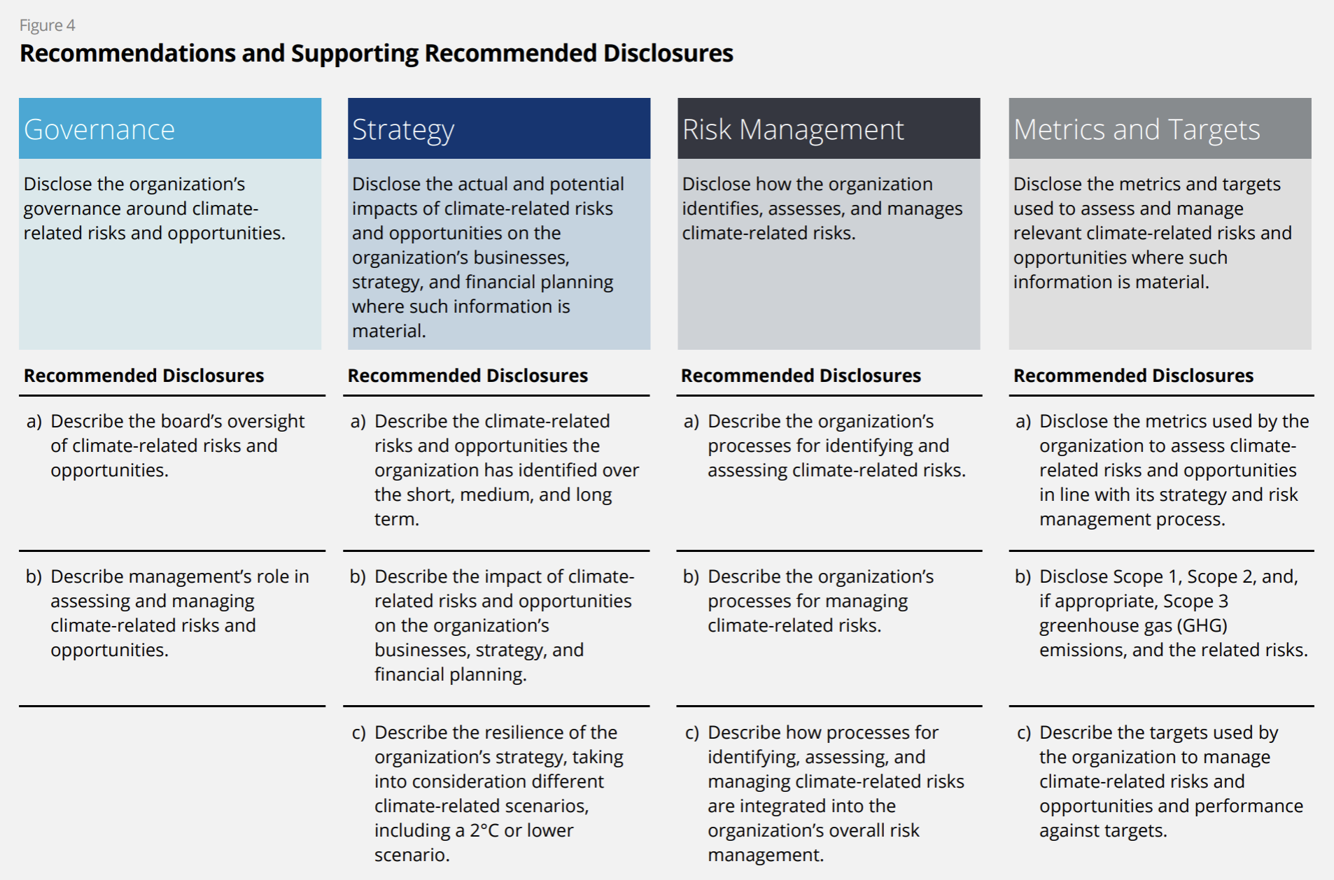

|  |  |
| --- | --- |
| **Company & link** | **Is structured?** |
| [**ABN AMRO**](https://assets.ctfassets.net/1u811bvgvthc/3xQYD4WZ5IkMON5qOg9MUL/06808331e445b105f51436335f8f31dd/ABN_AMRO_Bank_Annual_Report_2019.pdf) | yes |
| [**AXA**](https://www-axa-com.cdn.axa-contento-118412.eu/www-axa-com%2F3800520b-ce0f-4aa7-908d-3ec367b21d39_2020_climate_report_axa.pdf) | yes |
| [**BHP**](https://www.bhp.com/-/media/documents/investors/annual-reports/2020/200910_bhpclimatechangereport2020.pdf) | yes |
| [**EY Global**](https://assets.ey.com/content/dam/ey-sites/ey-com/en_gl/topics/sustainability/ey-tcfd-report-2022.pdf) | yes |
| [**Macquarie Group**](https://www.macquarie.com/assets/macq/impact/esg/policies/tcfd-implementation-progress-and-scenario-analysis-fy20.pdf) | yes |
| [**QBE**](https://www.qbe.com/sustainability/climate-change) | Not pdf |
| [**Salesforce**](https://s23.q4cdn.com/574569502/files/doc_downloads/2021/10/Salesforce-TCFD-Report.pdf) | yes |
| [**TD Bank**](https://www.td.com/document/PDF/ESG/2020-TCFD-Report.pdf) | yes |
| [**Wolfspeed**](https://assets.wolfspeed.com/uploads/2022/10/Wolfspeed_Sustainability_Report_2022.pdf) | yes |
| [**Xcel Energy**](https://s25.q4cdn.com/680186029/files/doc_downloads/2023/01/Managing-Risks-Opportunities-in-the-Net-Zero-Transition-(TCFD-Response).pdf) | Not found |